Joining and Participating in a Zoom Webinar (attendee)

Prerequisites
Zoom Desktop Client or Mobile App
If you have not used Zoom before, log in a few minutes early so you can download the desktop app. You can also download the mobile app on iOs or Android.

Accessing the Webinar
You can join via computer and use your computer audio and webcam. You can also join via computer to see our screen share and other participants, but dial in to use your phone audio.

Once You Are On the Webinar

Audio Settings (only visible if the host hasn't granted you permission to talk): Change your audio settings. You can also click the upward arrow (^) next to change your speaker.
Unmute/Mute: If the host gives you permission, you can unmute and talk during the webinar. All participants will be able to hear you. If the host allows you to talk, you will receive a notification.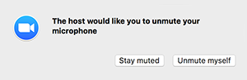
Note: You can still access the audio settings by click on the ^ arrow next to the Unmute/Mute button.
Chat: Open in-meeting chat, allowing you to send chat messages to and send a message to the host, panelists, and attendees (if permitted).
Raise Hand: Raise your hand in the webinar to indicate that you need something from the host. The host may instruct you on how they plan to use this. Many webinar hosts use this feature to know if an attendee has a question and would like to speak out loud.
Question & Answer: Open the Q&A window, allowing you to ask questions to the host and panelists. They can either reply back to you via text in the Q&A window or answer your question live.
To ask a question:
- Type your question into the Q&A box. Click Send.
Note: Check Send Anonymously if you do not want your name attached to your question in the Q&A.
- If the host replies via the Q&A, you will see a reply in the Q&A window.
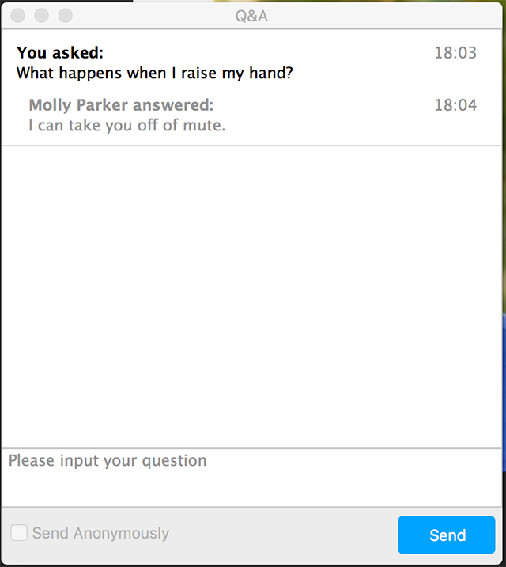
The host can also answer your question live (out loud). You will see a notification in the Q&A window if the host plans to do this.
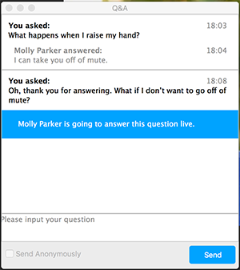
As an attendee you can also like or comment on other attendee’s questions. This helps the host or participant identify popular questions, especially in a webinar with many attendees.
- Click the thumbs up icon to like a comment.
Tip: The number beside the icon is the total number of likes the question has received so far.
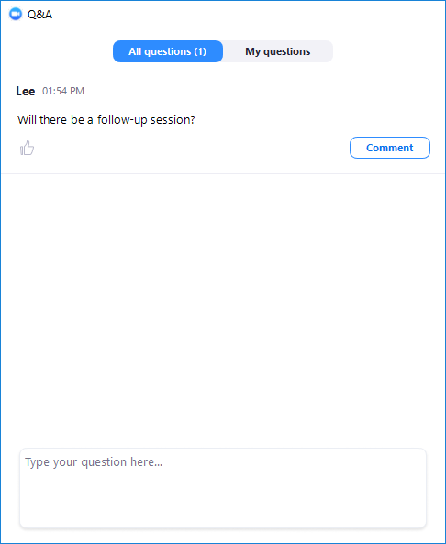
- Click the red thumbs up icon to unlike a comment.
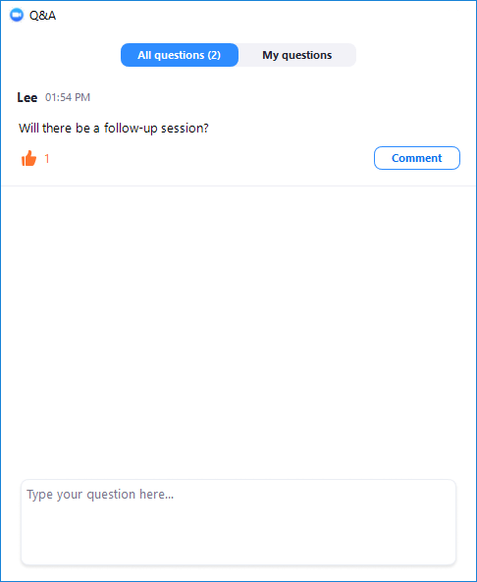
- Click Comment to write a reply to an existing question.
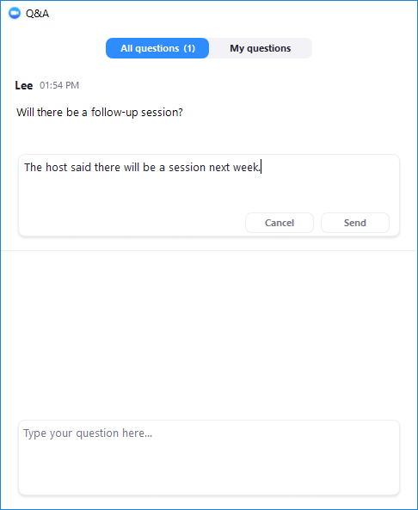
- Type your comment and click Send.
Your comment will appear beneath the question.
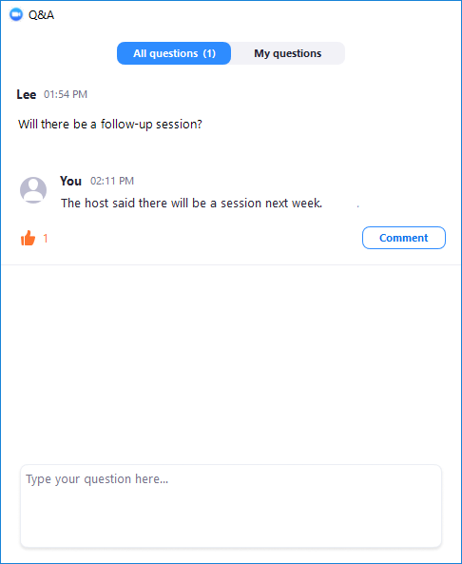
Leave meeting: Click Leave meeting to leave the webinar at any time. If you leave, you can rejoin if the webinar is still in progress, as long as the host has not locked the webinar.

